It is one of the approach to crack virtual box:

**After downloading the .ova file follow the below steps to capture the Flag:**

1. Open virtual box, top left corner click on -->File --> import as shown below

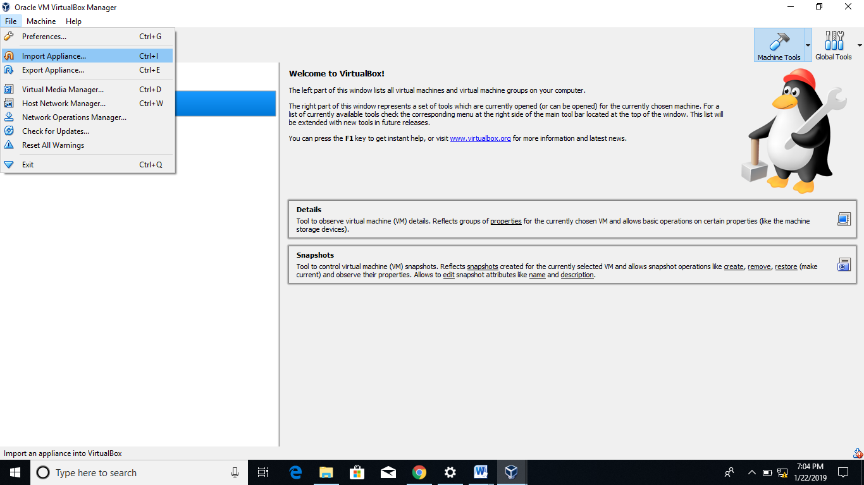

1. Search .ova file from your Downloads

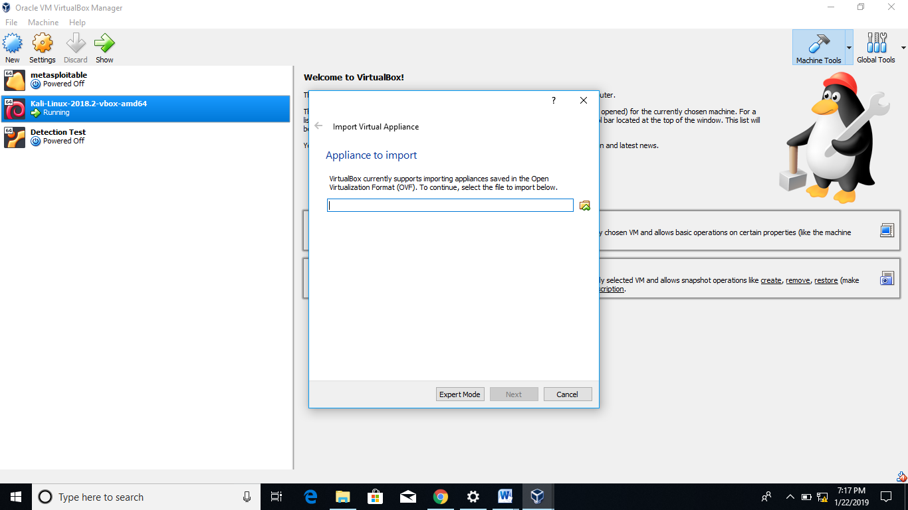

1. Click on import after searching, it will take some time for importing.

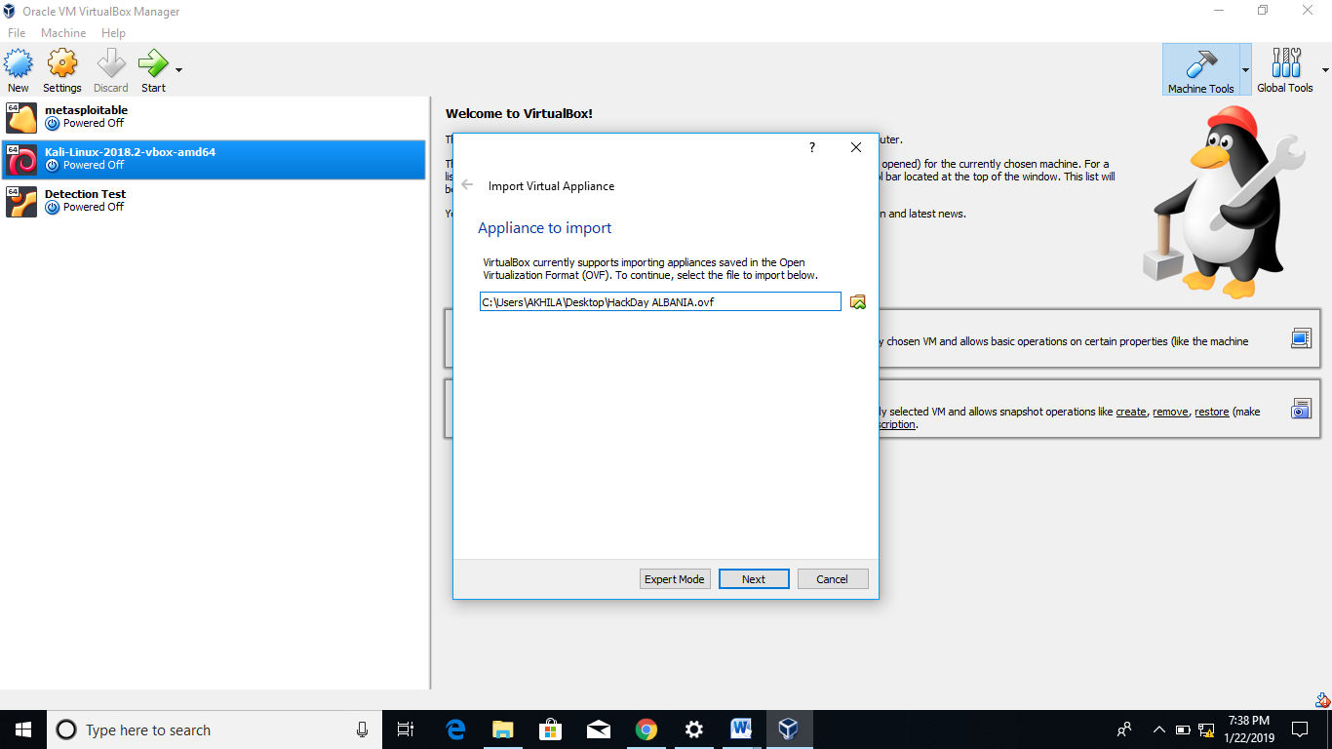

1. now start your ubuntu which is named as Detection Test

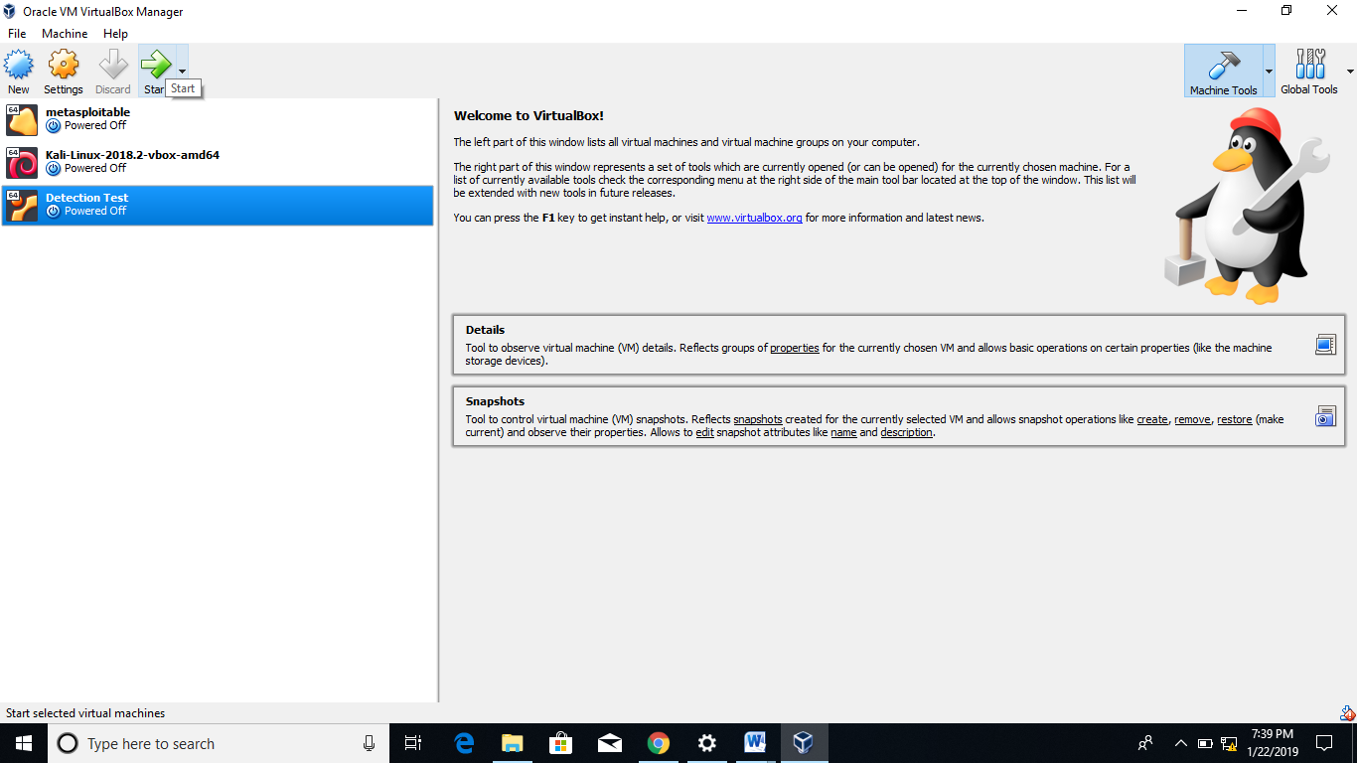

1. After opening ubuntu you will get this screen as shown below, To Capture the flag you need to know "username" & "password"

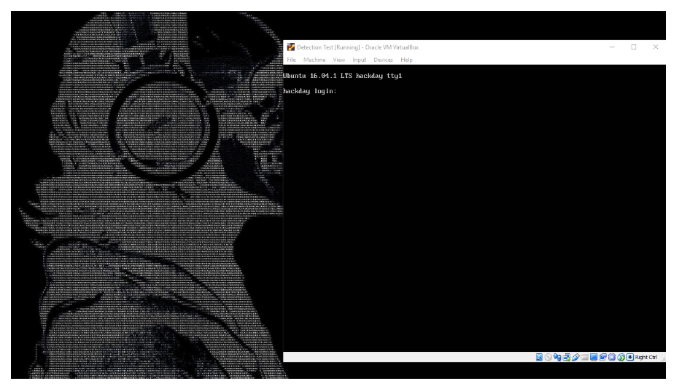

1. So to Crack username and password restart your virtual ubuntu
2. Once you reboot to Grub menu, select the first menu item or the menu item you normally use to boot your Ubuntu system and press e to edit:

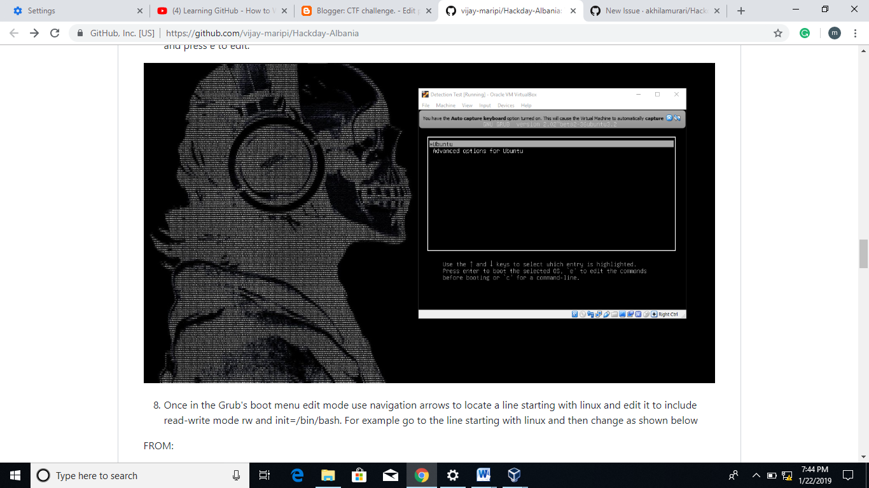

1. Once in the Grub's boot menu edit mode use navigation arrows to locate a line starting with linux and edit it to include read-write mode rw and init=/bin/bash. For example go to the line starting with linux and then change as shown below

FROM:

linux /boot/vmlinuz-4-4.0-22-generic root=UUID=43ad24d3-e  
c5b-44ee-a099-a88eb9520989 ro quiet splash $vt_handoff

change to:

linux /boot/vmlinuz-4-4.0-22-generic root=UUID=43ad24d3-e  
c5b-44ee-a099-a88eb9520989 rw init=/bin/bash

1. Once ready press CTRL+x or F10 to boot.
2. If all went well you should now see root shell command line and your root partition should be mounted with read/write flags. To confirm run:

root@(none):/# mount | grep -w /

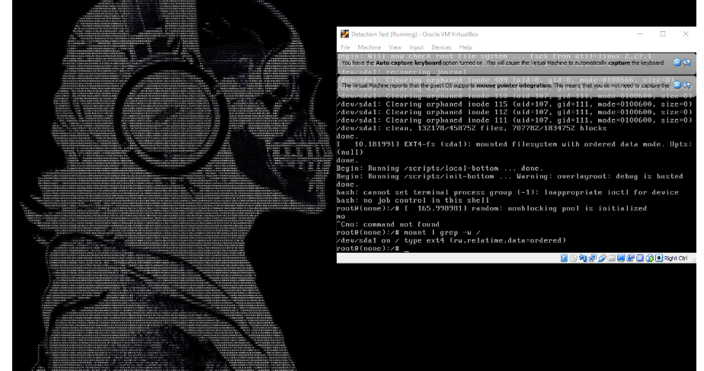

1. Now we are ready to reset root's password. To do so, simply run passwd command with no arguments. When prompted enter your new root password:

root@(none):/# passwd

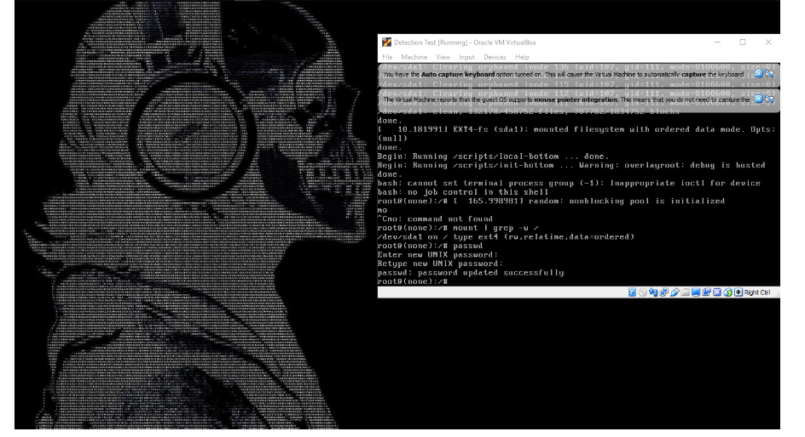

1. Reboot your system using the following linux command:

root@(none):/# exec /sbin/init

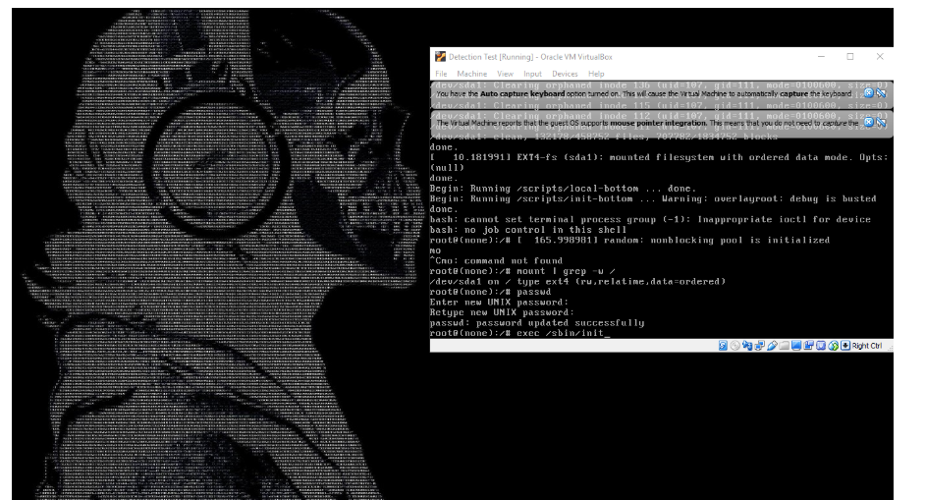

now press enter and then wait until login screen appears.

1. After that use username: root and password is what you kept.

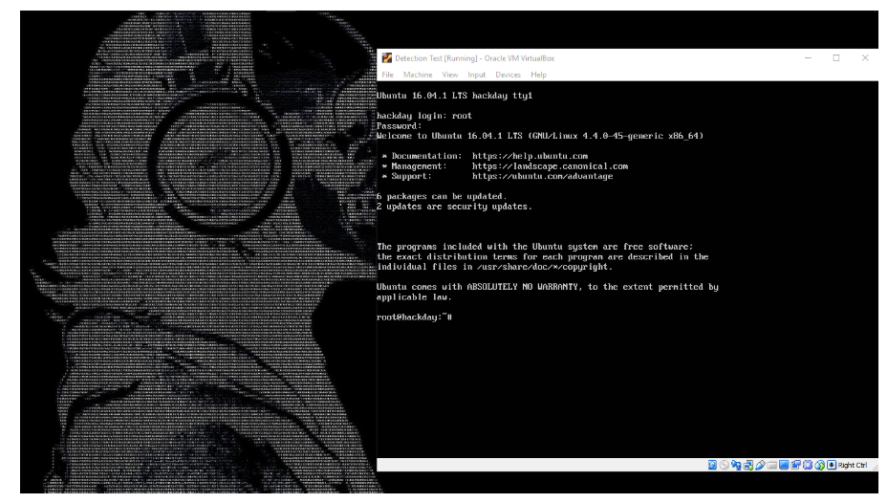

Type command: ls to check the files

1. There is text a file named flag.txt. I think this is our flag so lets see what's there inside the file.

use command: root@hackday:cat flag.txt

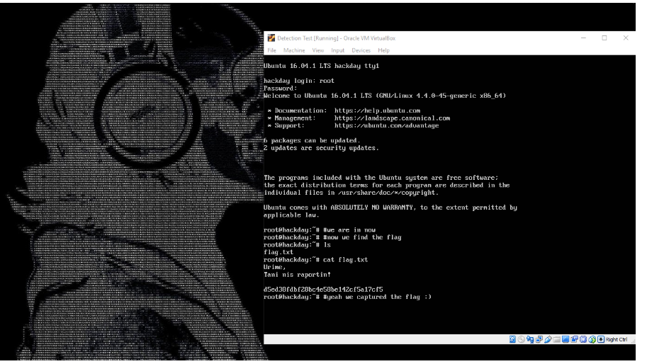

Now at last u will capture the flags.

Remember one thing no system is safe.

Go on exploring we can crack the system .

HAPPY HACKING.